**Project Development Phase**

**Model Performance Test**

|  |  |
| --- | --- |
| Date | 10 NOvember 2022 |
| Team ID | PNT2022TMID42499 |
| Project Name | Web Phishing Detection |
| Maximum Marks | 10 Marks |

**Model Performance Testing:**

Project team shall fill the following information in model performance testing template.

|  |  |  |  |
| --- | --- | --- | --- |
| **S.No.** | **Parameter** | **Values** | **Screenshot** |
|  | Metrics | **Classification Model: Random Forest Classifier** Confusion Matrix – Refer Screenshot  Accuray Score- 96.70%  & Classification Report – Refer Screenshot |  |
|  | Tune the Model | Hyperparameter Tuning -  Validation Method - | - |
|  |  |  |  |

**1.METRICS**

**CLASSIFICATION MODEL: RANDOM FOREST CLASSIFIER**

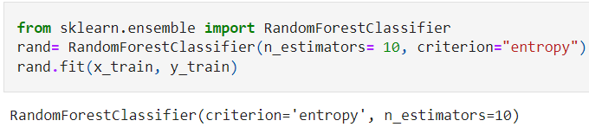

**EVALUATION METRICS:**

